# Instructions for Installing and Configuring a Single Node Cassandra Database

The Cassandra database is installed and configured for production use onto a cluster of several virtual machines. For exploring the use of this technology on a small scale, however, it is possible to set it up to execute on a single virtual machine which is what these instructions describe. The installation proceeds in two phases: create a virtual machine and then install and start Cassandra.

## Section 1: Instructions for setting up an EC2 instance (virtual machine)

1. Select “Services” on the AWS console. Then select “EC2”



1. Launch a new EC2 instance by clicking on “Launch Instance”



1. Select the Ubuntu 18.04 Amazon Machine Image (AMI)



Select an instance (VM) type of m4.xlarge

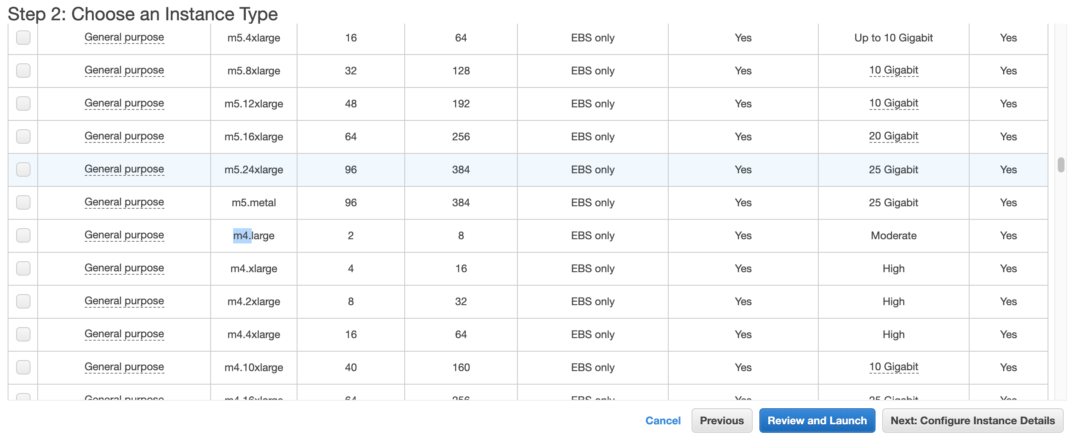

1. Select “Next: Configure Instance Details”



1. Select “Next: Add Storage”



1. Change the root storage size from 8 GiB to 32 GiB. Then select “Review and Launch”



1. Now “Launch” the instance



1. Select an existing key pair (or create a new pair). You can use the same key pair you created for your EMR instances. Make sure to check the “I acknowledge…” checkbox.



1. You should see this. Select “View Instances”



1. Wait until the instance state is “running”. Note that the public address (Public DNS) is provided for use in connecting via ssh or scp to the instance.



1. Now you can ssh to the instance the easy way as follows.
   1. Make sure you check the EC2 instance
   2. Click on the “Connect” button.



c) Select the “SSH Client” tab



d) Cut and paste the example ssh command that appears into your terminal to connect to your instance



Note that in this case the user name of your account is “ubuntu” and the address of your instance <Public DNS (IPv4)> is also used. So the ssh command about is built as follows. Note <Public DNS (IPv4)> is replaced with the actual value listed in the previsouly shown instance information pane.

1. Now you can ssh to the instance as follows.

ssh -i emr-key-pair.pem ubuntu@<Public DNS (IPv4)>

## Section 2: Instructions for installing Cassandra

1. Run below commands to install Java 8 on Ubuntu:

sudo apt update

sudo apt install openjdk-8-jdk openjdk-8-jre

1. Install the apt-transport-https package that is necessary to access a repository over HTTPS:

sudo apt install apt-transport-https

1. Add the Apache repository of Cassandra to /etc/apt/sources.list.d/cassandra.sources.list.

Import the repository’s GPG using the following wget command. The command should output OK which means that the key has been successfully imported and packages from this repository will be considered trusted:

wget -q -O - https://www.apache.org/dist/cassandra/KEYS | sudo apt-key add -

Next, add the Cassandra repository to the system by issuing (all on one line):

sudo sh -c 'echo "deb http://www.apache.org/dist/cassandra/debian 311x main" > /etc/apt/sources.list.d/cassandra.list'

1. Update the repositories:

sudo apt update

1. Install Cassandra:

sudo apt install cassandra

The Cassandra service will automatically start after the installation process is complete. You can verify that Cassandra is running by typing:

nodetool status

You should see something similar to this:

Datacenter: datacenter1

=======================

Status=Up/Down

|/ State=Normal/Leaving/Joining/Moving

-- Address Load Tokens Owns (effective) Host ID Rack

UN 127.0.0.1 114.55 KiB 256 100.0% d8c27e24-ea26-4eeb-8

1. You can start or stop Cassandra manually with

sudo service cassandra start

sudo service cassandra stop

1. You can start the Cassandra Query Language Shell with the following. Do this to do the assignment exercises:

cqlsh